- In the settings page – We should have option to add roles for all other except for doctor. Whenever a doctor is registered through the doctors page -> Add Doctor, we are putting in the email ID and creating a temporary password for the doctor. This should be his first sign-in Credentials – but only for the first time when the doctor is entering through his temporary password – the screen should prompt to mandatorily change password. Once the password is changed and the doctor re-logs in – he should see his user defined roles screen
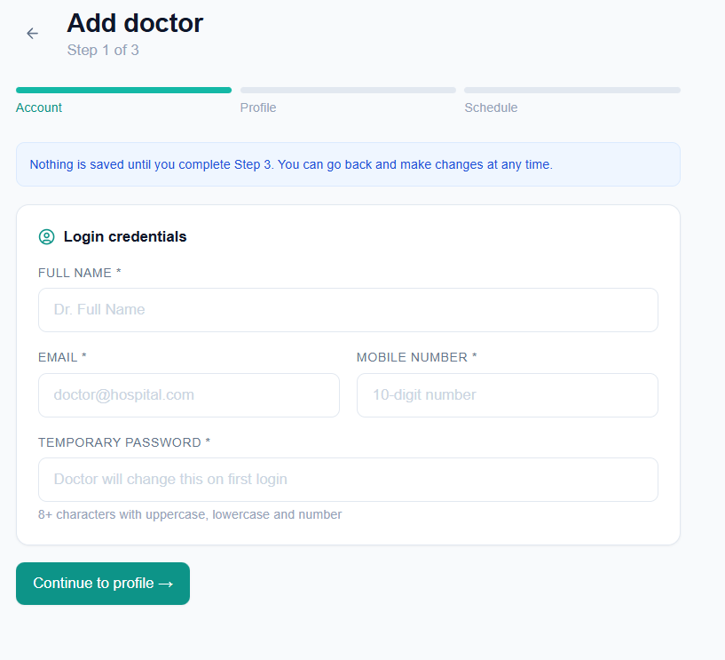

- In the settings page – upon adding staff – it is showing “Failed to load staff list” although the staff details are getting saved
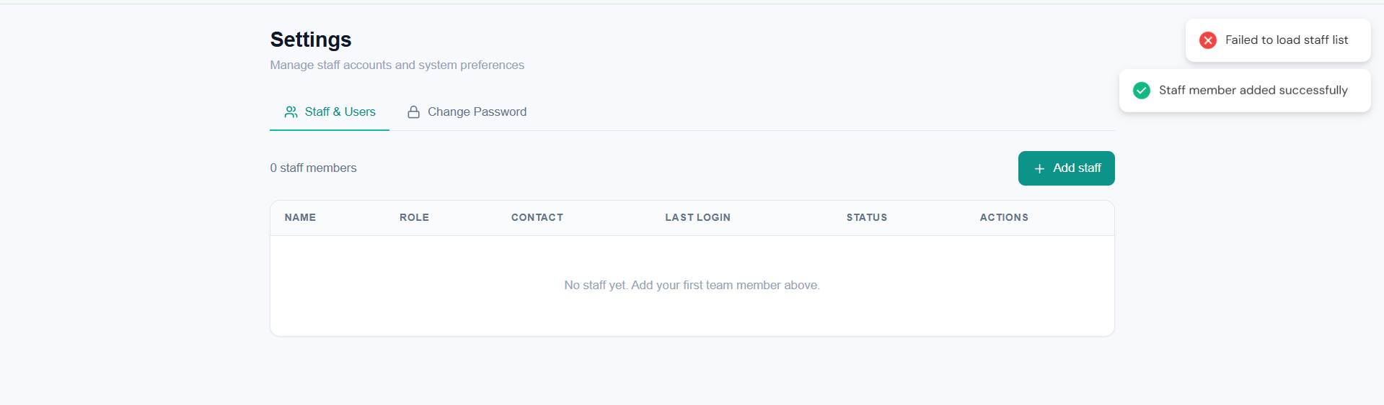
- “Too Many login attempts” message should appear for cases if the Username is entered correctly but incorrect password is entered 3 times. But currently even if I type a different username and wrong password for the third time – it blocked login to all usernames for 15mins
